**Exp. No.: 04**

**Date: 09/10/2024**

**Name: R .PRASANNA**

**Reg. No.: 2116231701039**

**Aim:**

To create a app for the donation application using figma .

**Procedure:**

1. Decide what needs to be improved and gather input from users.
2. Look at similar apps and gather feedback on the .
3. Draw basic layout ideas on paper and create simple wireframes in Figma.
4. Start a new Figma project, set up pages, and create reusable design elements.
5. Design the grid with categories and item tiles, including images, names, descriptions, and prices and user details.
6. Prototyping should be done to connect the frames to fulfill the app requirement.
7. Show the app to users and make changes based on their feedback.

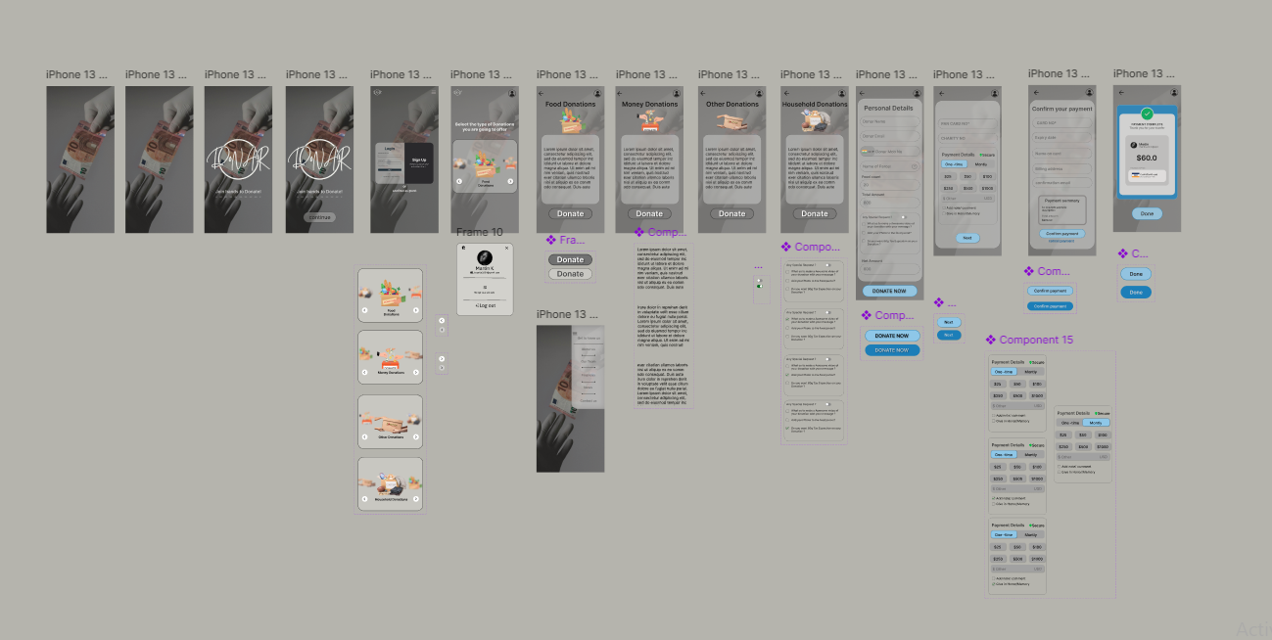

**Result:**

Using Figma created a app for the donation application .